The rock cycle


1. Fill in the blanks with the following words and translate the passage into French.
“fine-grained”, “surface”, “loose”, “mountain, “textures”, “silicate”, “porphyry”, “solid”, “volcanic”, “molten”

Rocks






Geologists separate rocks into three classes based on how they form: igneous rocks, sedimentary rocks, and metamorphic rocks. Igneous rocks form when a hot, ……….1………. liquid called magma solidifies. Sedimentary rocks form when ……….2 sediment,
such as sand and clay, becomes cemented to form a ……….3……….


rock. Metamorphic rocks form when older igneous, sedimentary, or other metamorphic rocks change because of high temperature and/or pressure or are deformed during ……….4 building.




The temperature of magma varies from about 600˚C to 1400˚C. Nearly all magmas are ……….5………. magmas. Magma usually rises toward the Earth’s surface because it is of lower density than rocks that surround it.

An extrusive, or ……….6………., igneous rock forms when magma erupts and solidifies on the Earth’s ……….7 An






intrusive, or plutonic, rock forms when magma cools and solidifies below the surface. Plutonic rocks typically have medium- to coarse- grained ……….8………., whereas volcanic rocks commonly have very fine- to fine-grained textures. A ……….9………. consists of larger crystals imbeded in a ……….10 matrix.
...........
.................................................................................................................
.................................................................................................................
.................................................................................................................
.................................................................................................................
.................................................................................................................
.................................................................................................................
.................................................................................................................

........................................................................................................
.................................................................................................................
.................................................................................................................
........................................................................................................
.................................................................................................................
.................................................................................................................
.................................................................................................................
.................................................................................................................
.................................................................................................................
........................................................................................

2. Match the sentence parts to form a complete sentence.
1
2
3
4
5
6

1. The marine fossils of Mount Everest tell us that | A) metamorphosed into schist.
2. Under certain conditions, rocks of the upper mantle and lower crust melt, | B) its temperature and pressure increase.
3. When the beach sand is cemented, | C) a coarse-grained rock forms.
4. When a rock is buried, | D) the limestone formed in the sea.
5. When magma cools slowly | E) forming a hot liquid called magma.
6. Shale when buried and heated to high temperatures (300- 500˚C) | F) it becomes sandstone.

3. Label the missing parts of the rock cycle.

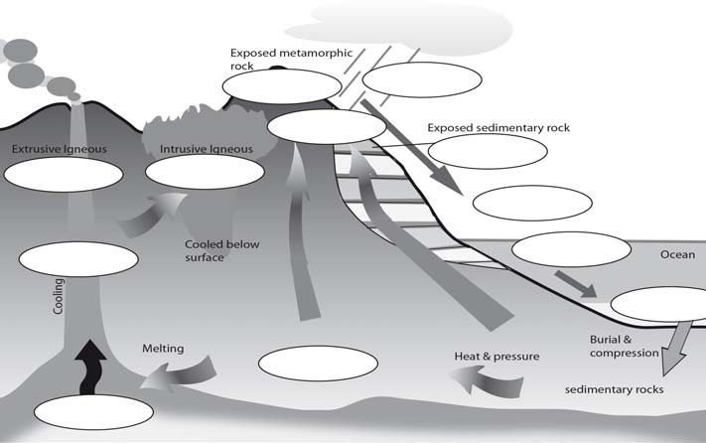
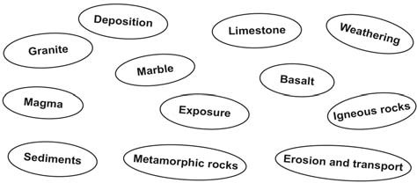


4. Write the name of relevant types of rocks in front of the corresponding definition and put the examples into the table too. “marble”, “granite”, “limestone”, “coal”, “slate”, “basalt”, “sandstone”, “shale”, “lava”.

Types | Definition | Example
 | These rocks were formed from the remains of animals or plants and other rocks which had been crushed together.
These rocks were formed when hot, molten
volcanic material cooled and solidified.
 | These rocks were once igneous or sedimentary and were changed by great heat and pressure.

